SRI ASNM GOVERNMENT COLLEGE (A)
PALAKOL

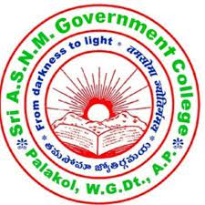

CAREER GUIDANCE CELL

REPORT

2023-2024

AIMS OF THE CAREER GUIDANCE CELL :
1) To motivate the students to get knowledge appear for competitive examination.
2) In view of the heavy competition to acquire Knowledge to face and fulfil the goal through Career Guidance cell.
3) Accurate Various types of leaching technique will be helpful to the aspirants to crack- Bank, APPSC, UPSC, and other Government Sector Jobs.

OBJECTIVES:
The main objective of the program is to motivate the students to study for competitive exams in the UG level to get the opportunities in the services. The main objectives of programme is to inculcate the interest among the students to study the Career guidance to receive great opportunities in their near future.
1. Career Guidance is a stream is most rewarding for students who are passionate and talented.
2. Low entry barrier at most colleges enable quick and easy admission process.
3. Fee structure and duration of classes is comparatively lower .
4. To mold themselves to achieve Service oriented job opportunities
5. To get opportunities in the Government Departments and Sectors.

OUT COME:

Under the careful guidance of our Principal Dr. T. RAJA RAJESWARI, all the students attended the program. They express their gratitude towards the program. The students interacted with the faculty to gain more knowledge and clear any doubts. The program is veryuseful to the students to setting a goal and they know about their strengths. The program isvery useful to understanding of work. It is very useful to enhancing their personal skills.

COMITTEE MEMBERS
SL.NO | NAME OF THE STAFF | DESIGNATION | ROLE
1 | T.KRISHNA | LECTURER IN POLITICAL SCIENCE | ADVISOR
2 | SRI. K. PARDHA SARATHI | CONTRACT LECTURER IN HISTORY | MEMBER
3 | SMT V.SIRISHA | CONTRACT LECTURER IN BOTANY | MEMBER
4 | SRI. P.SRINIVAS | CONTRACT LECTURER IN BOTANY | MEMBER
5 | SMT. B.V.R.K. RAMA LAKSHMI | CONTRACT LECTURER IN MATHEMATICS | MEMBER
6 | SMT.P. DURGESWARI | GUEST LECTURER IN COMMERCE | MEMBER
7 | SMT. K. SWARNALATHA | GUEST LECTURER IN COMMERCE | MEMBER

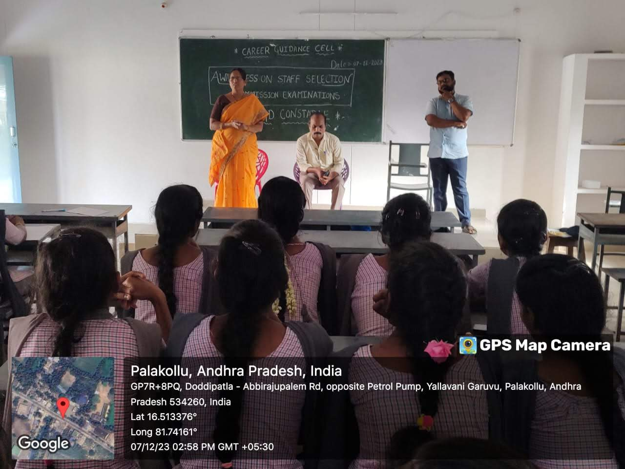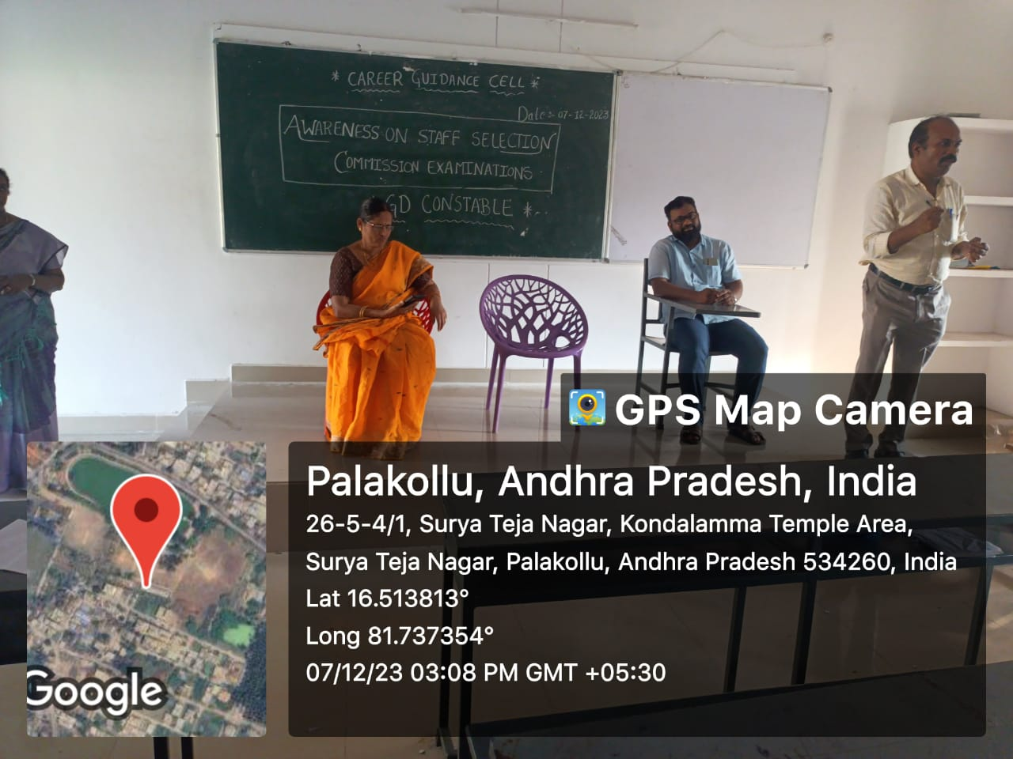

S.No | 1
Name of the activity | Academic & Administrative Structure , Learning Resources
Date of conducting the activity | 09 August 2023
Organized by Dept./Committee | Economics
Name of the Resource Person | Dr. T. Raja Rajeswari
No. Of students participated | 50
Detailed report of the activity | The Principal apprising about this activity said about the greatness of the college and Patanjali garu – Superintendent of the college spoke about thew uses of clerical department of the college. Dr. Ch. Usha Rani spoke about the various department of the college. Learning resources are those recourses that the teacher use to help learns to meet the expections for learning which are defined by the curriculum. They can also be defined as materials used by a teacher to add value to the instructions given by the teacher and to simulate the interest of the learns present.
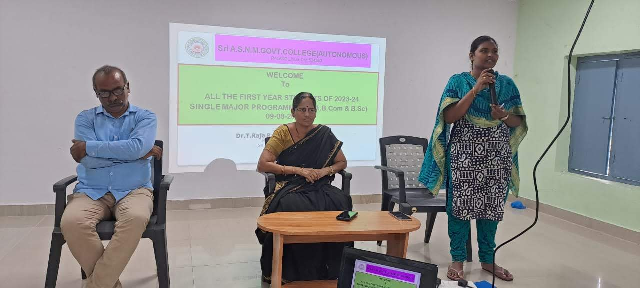

S.No | 2
Name of the activity | Life skills including effective communication
Date of conducting the activity | 10th August 2023
Organized by Dept./Committee | English
Name of the Resource Person | Sri Dinakaran
No. Of students participated | 40
Detailed report of the activity | The Lecturer Sri Dinakaran talked about the usage of language in effective communication. Especially about English and its use as an international communicative language * Definition and scope of life skills. * Role an importance of life skills. * Characteristics of life skills. * Life skills is employability skills. * Life skills transforming into communication skills. *Types of communication skills.  * Role and syndications and role of communication. * Word and writing skills. * Reading for speaking. * Vocabulary.
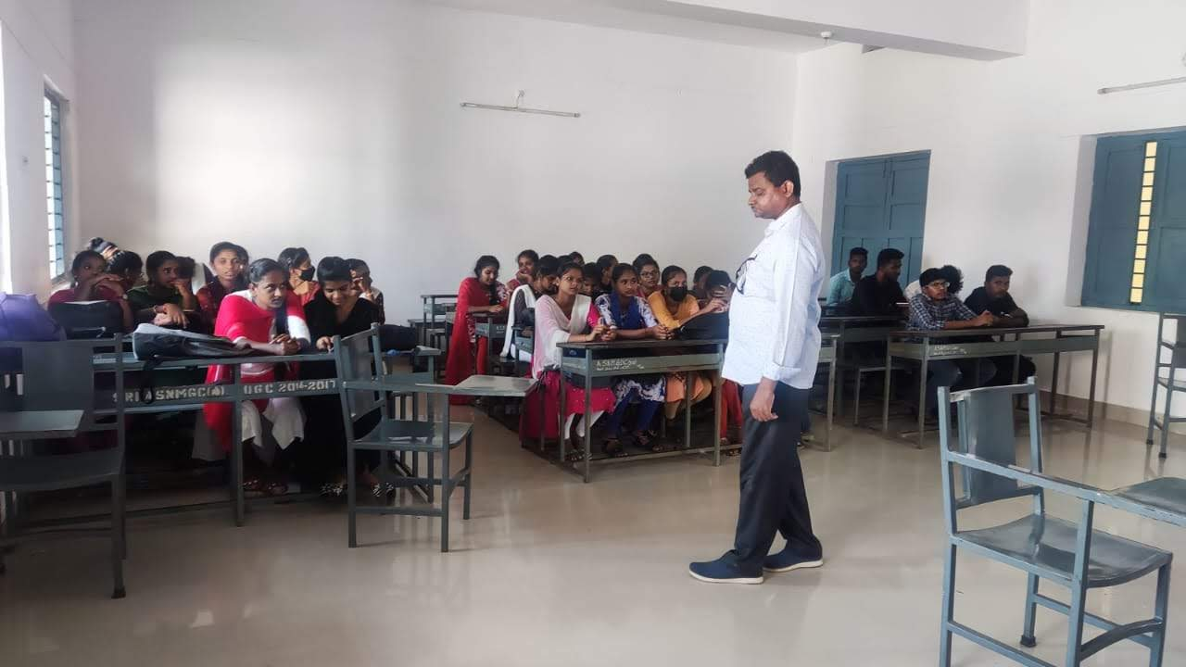

S.No | 3
Name of the activity | Interpersonal skills, self awareness, empathy, Coping with stress.
Date of conducting the activity | 14th august 2023
Organized by Dept./Committee | English
Name of the Resource Person | G.D. Srinivas
No. Of students participated | 50
Detailed report of the activity | The spokesperson told about the coping of stress in Education and talked about the development of interpersonal skills &self awareness in all round development. Interpersonal skills are essential in today’s interconnected world and they encompass are range of abilities crucial for effective communication and relationships. Self-awareness forms the foundation of these skills, as understanding our own thoughts, emotions, and behaviors enables us to interact authentically with others. Empathy, another vital component, allows us to comprehend and share the feelings of those around us, fostering deeper connections and better collaboration additionally, coping with stress is a key aspect of interpersonal competence, as it enables us to maintain composure and resolve conflicts constructively, ultimately contributing.
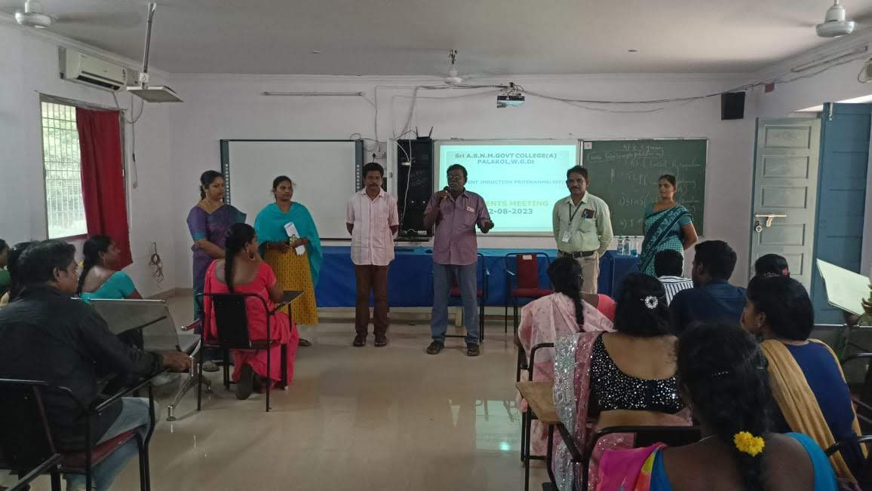

S.No | 4
Name of the activity | Problem solving , Decision making , Critical thinking
Date of conducting the activity | 16th. August 2023
Organized by Dept./Committee | Mathematics
Name of the Resource Person | K. Siva Krishna
No. Of students participated | 50
Detailed report of the activity | The lecturer in Mathematics Sri K. Siva Krishna Taught the students about Decision making, Critical thinking and awareness of problem solving aroundthe environment of the Student. Analyse problems in new and different ways, recognize the building blocks of critical thinking, problem solving and decision making.  Collect information or data on the issue through research. Organize and sort data and findings. Develop and execute solutions. Critical thinking and problem solving skills enable students to communicate effectively and work effectively with others to solve problems an achieve goals.
(No photo Available)
S.No |  | 5
Name of the activity |  | Curricular, co-curricular and Extracurricular for all round and holistic development.
Date of conducting the activity |  | 17th august 2023
Organized by Dept./Committee |  | Chemistry
Name of the Resource Person |  | - Vamsi Subbarayan
No. Of students participated |  | 50
Detailed report of the activity |  | The chemistry lecturer sri Vamsi talked about the academic activities useful to the students and extra curricular activities useful to t he students in development of personality. Internal Sources: Academic Curriculum: The college's curriculum for science, arts, and commerce is designed to provide a well-rounded education, fostering critical thinking and problem-solving skills. Library Facilities: The college has an automated library with a number of textbooks and reference books. The students are offered access to an extensive digital resources for enhancing their knowledge and research abilities. Mentoring Services: The college through faculty members offer mentoring for the emotional and psychological support, promoting mental well-being.  External Sources: Internships and Industry Collaborations: Partnering with local, district and state businesses and organisations allows students to gain practical experience and network in their chosen fields.
No photo available

S.No | 6
Name of the activity | 19th august 2023
Date of conducting the activity | Fundamentals of Computersbasic tools
Organized by Dept./Committee | Computer Science
Name of the Resource Person | Sri K. Badhrachalam
No. Of students participated | 45
Detailed report of the activity | Sri K. Badhrachalam lecturer in computer science talked about the importance of computer science in modern world and told the students to develop computer skills to further their job opportunities. Fundamentals of Computers useful for Interdisciplinary areas Computer fundamentals refers to the basics of using digital devices such as computers, smart phones and tablets. "Computer used to only refer to the basics of using a computer and associated devices; however, it has since expanded to include most frequently-used digital devices. Computer fundamentals are becoming more and more necessary in our increasingly digital world. The tools and knowledge to effectively use and utilize digital tools enables students to progress better in education as well as preparing them for daily tasks and careers in their future lives
No photo Available

S.No | 7
Name of the activity | Awareness about Career Guidance
Date of conducting the activity | 23rd August 2023
Organized by Dept./Committee | History
Name of the Resource Person | Sri K. Siva Prasad  Director Aandhra Coaching Center
No. Of students participated | 50
Detailed report of the activity | The resource person told the students about the importance of achieving great heights by writing competitive exams and getting success in it. Our programme focused on inspiring students to achieving great goals by getting good Government jobs.  Developing student capability for gaining Govt. Jobs on the occasion Sri.K.SivaPrasad of Andhra Coaching center was invited to teach the students on gaining goodpositions after completion of their education.
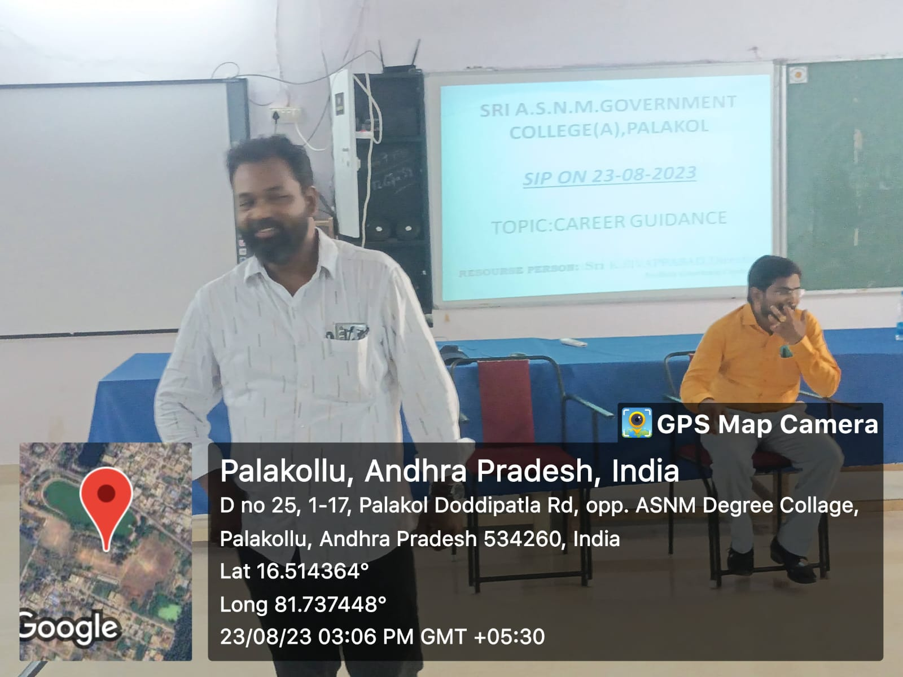

S.No | 8
Name of the activity | Community Service Projects & Internships
Date of conducting the activity | 29th august 2023
Organized by Dept./Committee | Department of Computer Applications
Name of the Resource Person | Ch. Ravi Kumar
No. Of students participated | 40
Detailed report of the activity | Sri Ch. Ravi Kumar spoke about the New Education policy, and short term and long term Internships
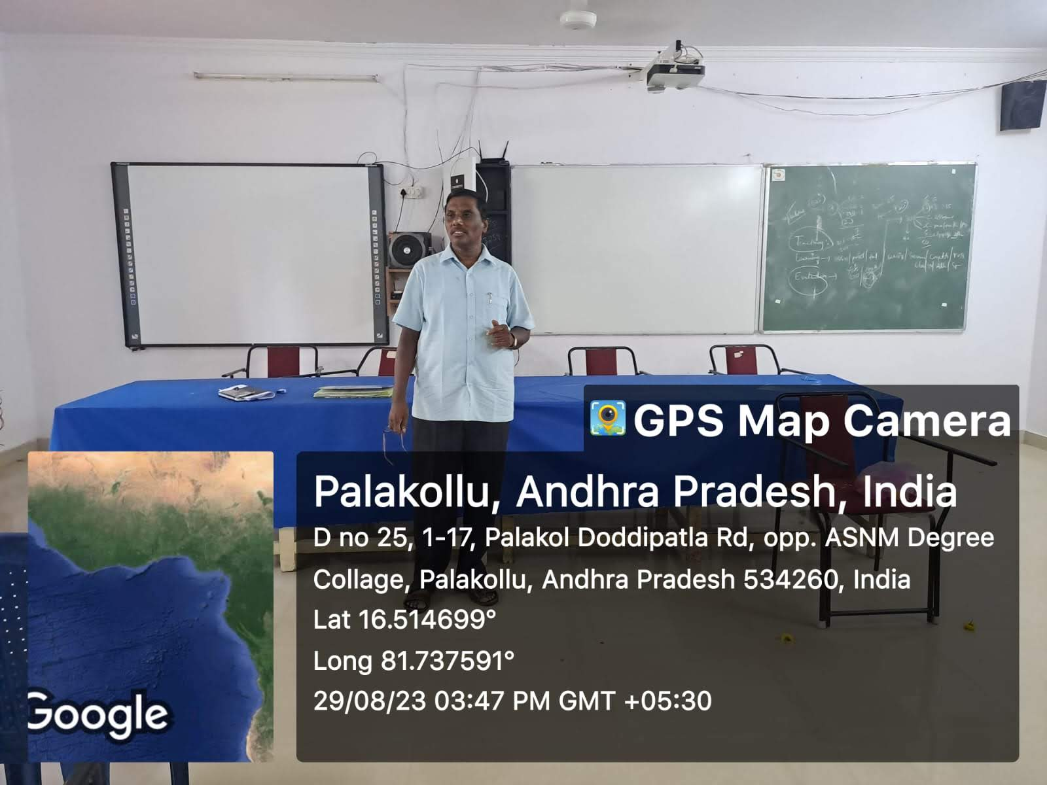

S.No | 9
Name of the activity | Inauguration of competitive coaching conducted by K. Siva Prasad Andhra coaching center
Date of conducting the activity | 7th December 2023
Organized by Dept./Committee | Career guidance cell
Name of the Resource Person | Dr. T raja rageswari devi
No. Of students participated | 35
Detailed report of the activity | The principal inaugurating the meeting informed the students about inculcating awareness about competitive examinations, and inform the students about their advantages of getting a government job

S.No | 10
Name of the activity | Arithmetic &Reasoning
Date of conducting the activity | 9th December 2023
Organized by Dept./Committee | Career guidance cell
Name of the Resource Person | K. S R Prasad
No. Of students participated | 50
Detailed report of the activity | The resource person Sri K. Siva Prasad told the students about Logic of using arithmetic & reasoning for competitive examinations and its usage during job mela, conducted by various colleges in West Godavari District.
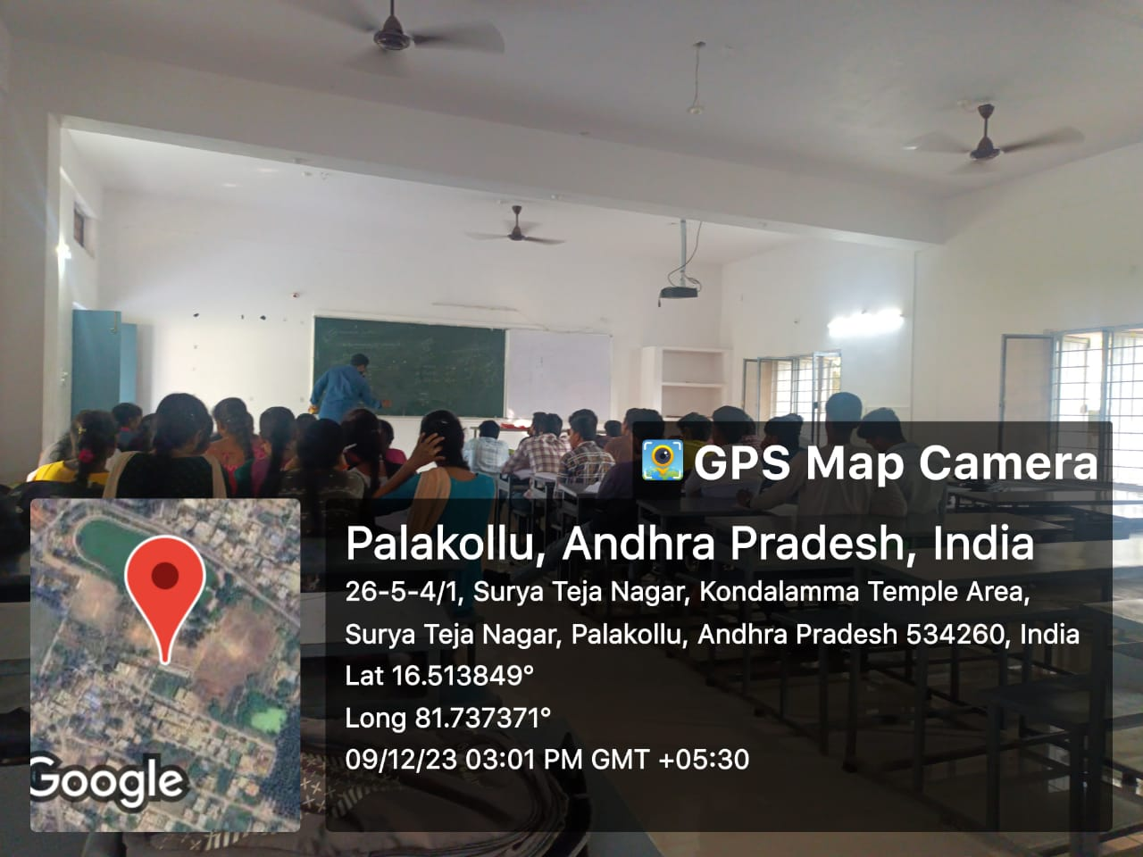

S.No | 11
Name of the activity | History for competitive examinations
Date of conducting the activity | 11th December 2023
Organized by Dept./Committee | Career guidance cell
Name of the Resource Person | K. Siva Prasad
No. Of students participated | 35
Detailed report of the activity | Sri. K. Siva prasad director AAndhra coaching center taught the students about the importance of History in all competitive examinations and also by knowing history one can realise how to cope with Society and administration.
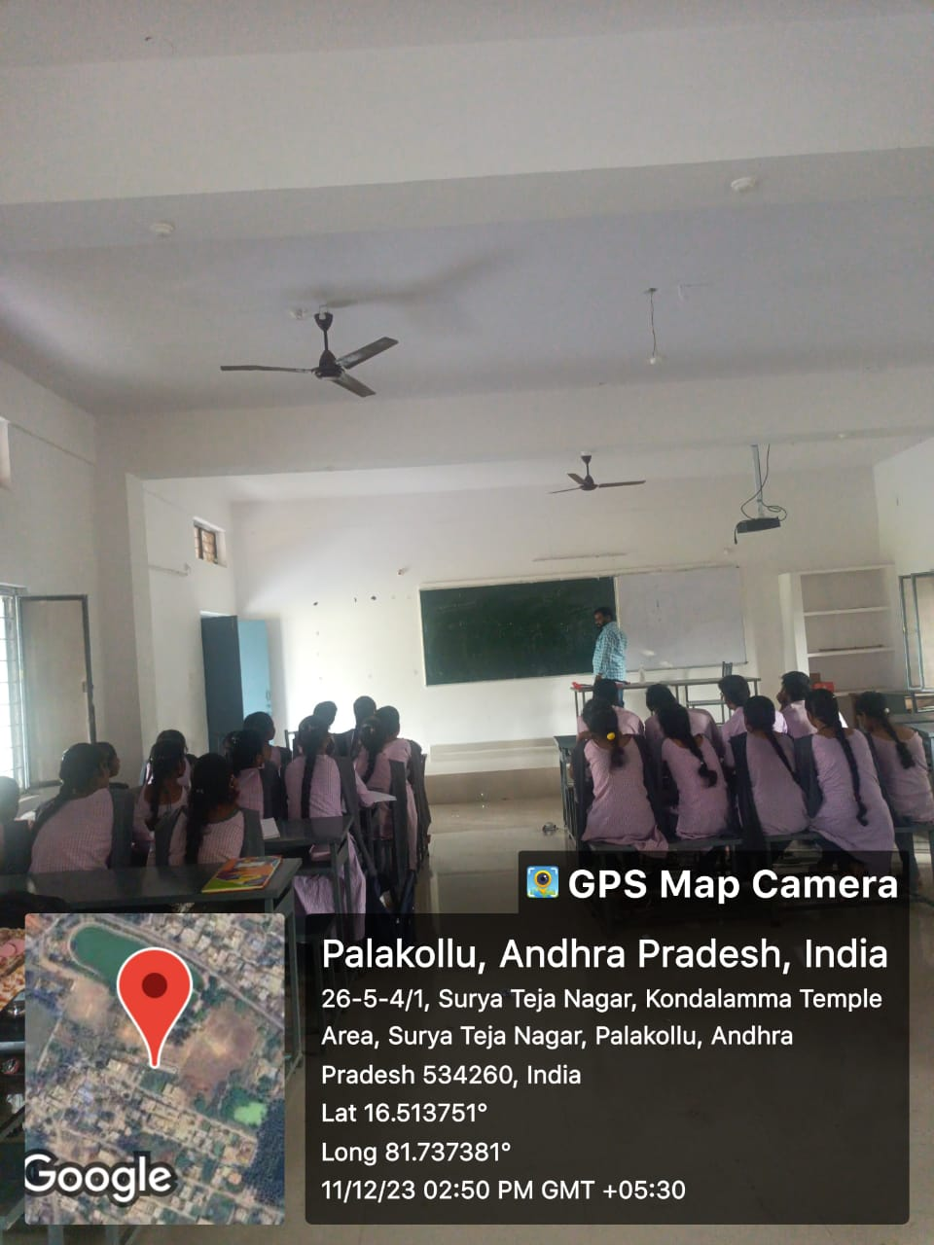

S.No | 12
Name of the activity | History for competitive examinations
Date of conducting the activity | 14th December 2023
Organized by Dept./Committee | Career guidance Cell
Name of the Resource Person | K. Siva Prasad
No. Of students participated | 40
Detailed report of the activity | Sri K. Siva Prasad director aandhra coaching centre advocated the students about the importance of history in daily life and how we can understand the problems of the society .
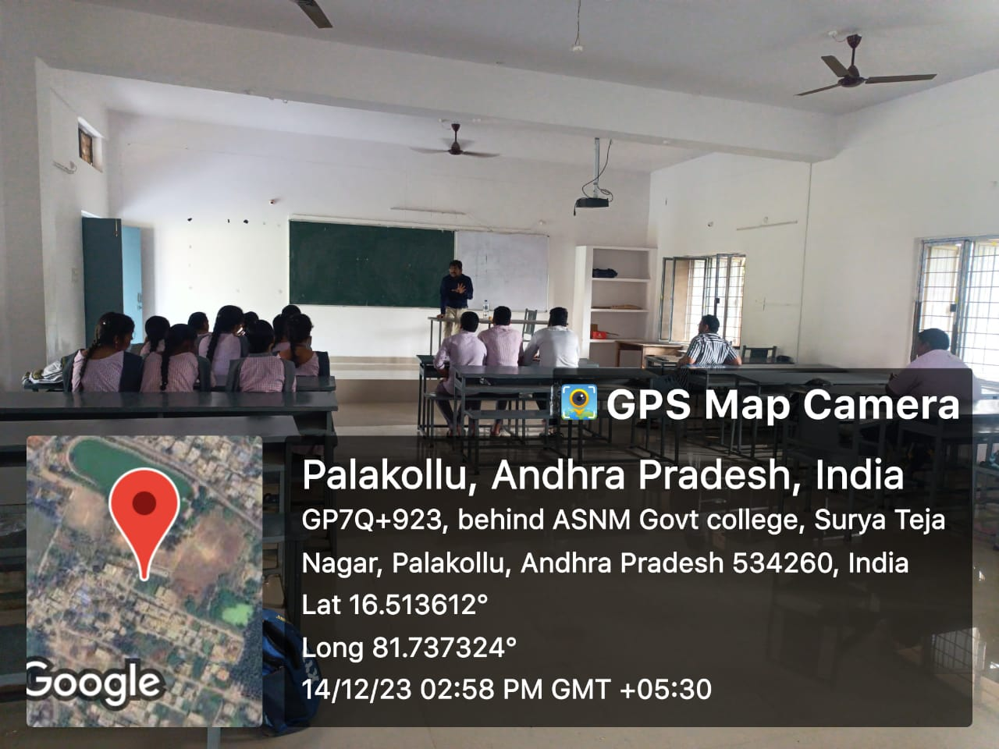

S.No | 13
Name of the activity | Political science for competitive examinations
Date of conducting the activity | 15th December 2023
Organized by Dept./Committee | Career Guidance Cell
Name of the Resource Person | K. Siva Prasad – Director Aandhra Coaching Center
No. Of students participated | 30
Detailed report of the activity | The Students were taught about the importance of political science, in understanding the political situation around them and learning about administration , society behavior and international relations.
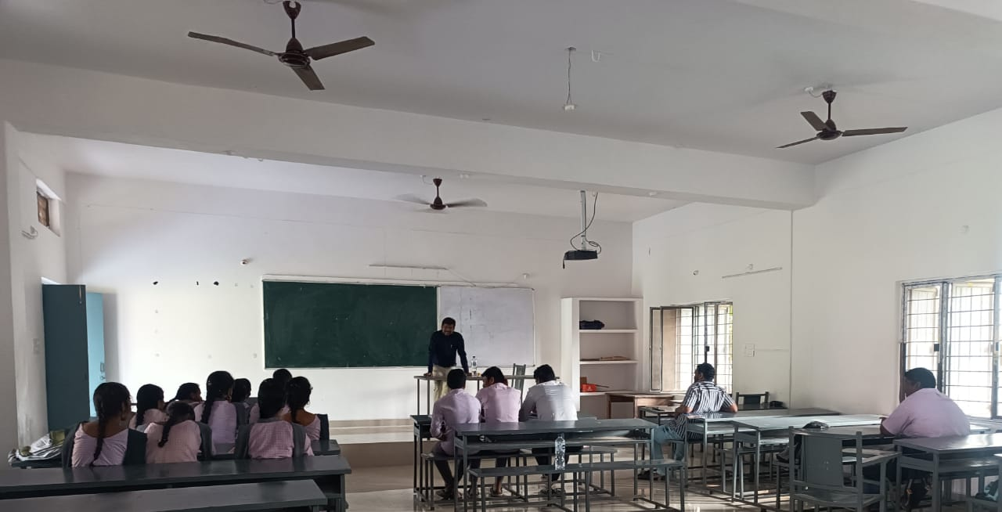

S.No | 14
Name of the activity | Arithmetic and reasoning
Date of conducting the activity | 18th December 2023
Organized by Dept./Committee | Career Guidance Cell
Name of the Resource Person | K. Siva Prasad – Director Aandhra Coaching Center
No. Of students participated | 20
Detailed report of the activity | Mr K. Siva Prasad interacting with the students about arithmetic and reasoning, old students about using Arithmetic and reasoning in daily life.
No photo available

S.No | 15
Name of the activity | Awareness on Staff Selection Examination,  GD Constable .
Date of conducting the activity | 07 -12- 2023
Organized by Dept./Committee | History
Name of the Resource Person | Dr. T. Raja Rajeswari
No. Of students participated | 35
Detailed report of the activity | The Principal on this occasion had appraised the students about the Staff Selection Commission Examination and motivated the Students to appear for Central Government Examinations. Speaking on the occasion the vice principal T.Krishna informed the students about the challenges in writing the staff selection commission examination. The guest of Honor, the director of Andhra Coaching Centre K. Sive Prasad inspired the students to get into central Government jobs. Regular classes for coaching were held from 7th December 2023 to 17th December 2023 on General studies, including Arithmetic and Reasoning
